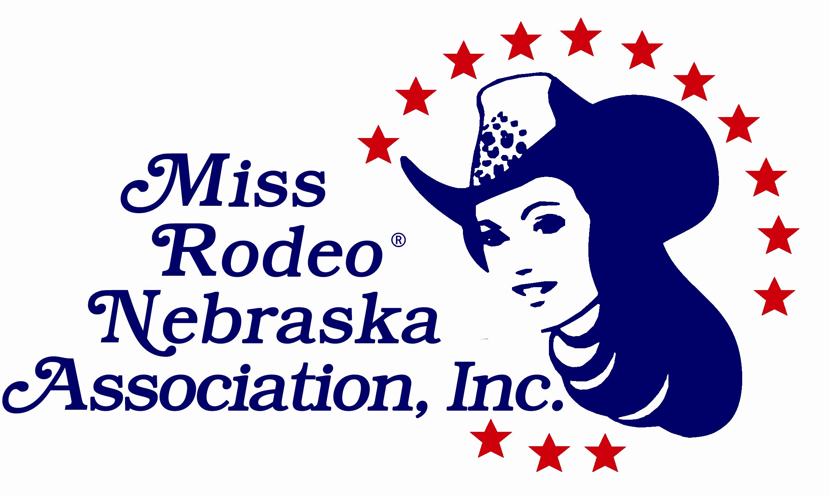 **MEMBERSHIP FORM**

The Miss Rodeo Nebraska Association, Inc. was organized in 1992 to promote western culture in Nebraska. Through our annual events and fundraisers, we are able to assist our **Miss Rodeo Nebraska** and **Miss Teen Rodeo Nebraska** in their representation of Nebraska and the sport of rodeo by enhancing their speech, interview, modeling and horsemanship skills and to present generous scholarships to them to further their education. Your membership makes you an important part of this effort. You will be able to participate in each girl’s journey from the moment she receives her title all the way through her year of travel and accomplishments. With prompt payment of your dues, it enables the Association to plan the programs for the coming year. Our mission statement aptly describes the purpose of this Association:

**To provide an opportunity for young women of high moral and ethical**

**character to promote Nebraska and the sport of rodeo.**

Please fill out the form below and return it with your membership dues to:

**Shari Schlichtemeier**

**512 East E Street**

**Ogallala, NE 69153**

If you need additional information, please email: [sharislick@opsd.org](mailto:sharislick@opsd.org) Please make checks payable to MRNA.

**NEW MEMBER – 2020**

Name:_________________________________________

Address:________________________________________

City:________________________ St:____ Zip:________

Phone:_________________ Cell:____________________

Email: ________________________________________

Please print very legibly – we communicate almost exclusively by email. If you do not wish to be contacted by email, please check the box. 🞎

$35.00 General Membership $_________

$10.00 Youth (16 & under) Membership $_________

$50.00 Rodeo Membership $_________

Plus $5.00 to receive newsletter by mail, $_________

(No fee to receive the newsletter by **email)**

**TOTAL AMOUNT DUE $_________**

Please indicate all committee(s) you would like to serve on:

____ Queen Clinic ____ Lil’ Cowgirls

____ Send-Off Style Show____Sponsorship

____ Scholarship ____ MRNA Officer

____ Other

Welcome!

**RETURNING MEMBER – 2020**

Name:_________________________________________

Address:________________________________________

City:________________________ St:____ Zip:________

Phone:_________________ Cell:____________________

Email: ________________________________________

Please print very legibly – we communicate almost exclusively by email. If you do not wish to be contacted by email, please check the box. 🞎

$35.00 General Membership $_________

$10.00 Youth (16 & under) Membership $_________

$50.00 Rodeo Membership $_________

Plus $5.00 to receive newsletter by mail, $_________

(No fee to receive the newsletter by **email)**

**TOTAL AMOUNT DUE $_________**

Please indicate all committee(s) you would like to serve on:

____ Queen Clinic ____ Lil’ Cowgirls

____ Send-Off Style Show____Sponsorship

____ Scholarship ____ MRNA Officer

____ Other

How many years have you been a member of MRNA? ____________

Thank You!